Paper Title (use style: Title)

(Font: Times New Roman 12 Bold

Author Name ª, Author Name ⃰ ^{b}, Author Name ^{c}, …. (Font: Times New Roman 9)
Corresponding Author E-mail : …………….
ª Affiliation (Font: Times New Roman 9)
^{b} Affiliation
^{c} Affiliation

Abstract: Write your abstract here, not more than 50 words. Please do not change the format of different parts of the text. (Font: Times New Roman 10)
Keywords: …………….; ……………………..; …………………….. (Font: Times New Roman 10)

Introduction
This template provides authors with most of the formatting specifications needed for preparing electronic versions of their papers [1]. All standard paper components have been specified for three reasons: ease of use when formatting individual papers, automatic compliance to electronic requirements that facilitate the concurrent or later production of electronic products, and conformity of style throughout a conference proceeding [2]. (Font: Times New Roman 10)

Experimental Section
The template is used to format your paper and style the text. All margins, column widths, line spaces, and text fonts are prescribed; please do not alter them. (Font: Times New Roman 10)

Results and Discussion
Before you begin to format your paper, first write and save the content as a separate text file. Keep your text and graphic files separate until after the text has been formatted and styled. (Font: Times New Roman 10)

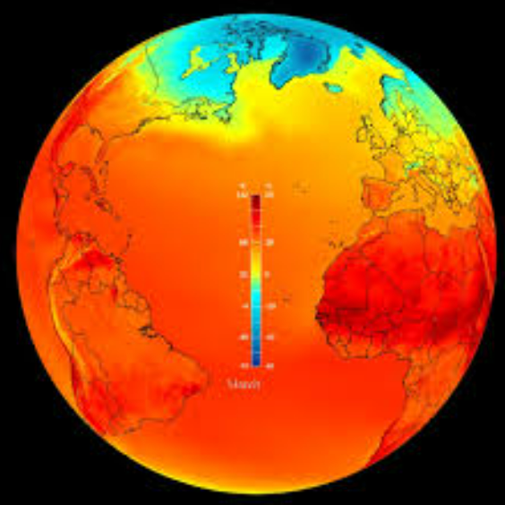
Fig.1: title ………………………(Font: Times New Roman 9)

Place figures and tables at the top and bottom of columns. Avoid placing them in the middle of columns. Large figures and tables may span across both columns. Figure captions should be below the figures; table heads should appear above the tables. (Font: Times New Roman 10)
Table1: Style1 (Font: Times New Roman 9)
Subhead | Subhead | Subhead
Copy (Font: Times New Roman 9) | Copy (Font: Times New Roman 9) | Copy (Font: Times New Roman 9)
Copy (Font: Times New Roman 9) | Copy (Font: Times New Roman 9) | Copy (Font: Times New Roman 9)
Copy (Font: Times New Roman 9) | Copy (Font: Times New Roman 9) | Copy (Font: Times New Roman 9)

Conclusions
After the text edit has been completed, the paper is ready for the template. Duplicate the template file by using the Save As command, and use the naming convention prescribed by your conference for the name of your paper. Font: Times New Roman 10).

References
[1] Chen, Y., Randall, A. A., & McCue, T. (2004). The efficiency of enhanced biological phosphorus removal from real wastewater affected by different ratios of acetic to propionic acid. Water Research, 38(1), 27-36. https://doi.org/10.1016/j.watres.2003.08.025. (Font: Times New Roman 10)
[2] You can use APA format in google scholar citation page
[3] ………………

